Forecast Growing Expenses Due to Inflation - Full Answer

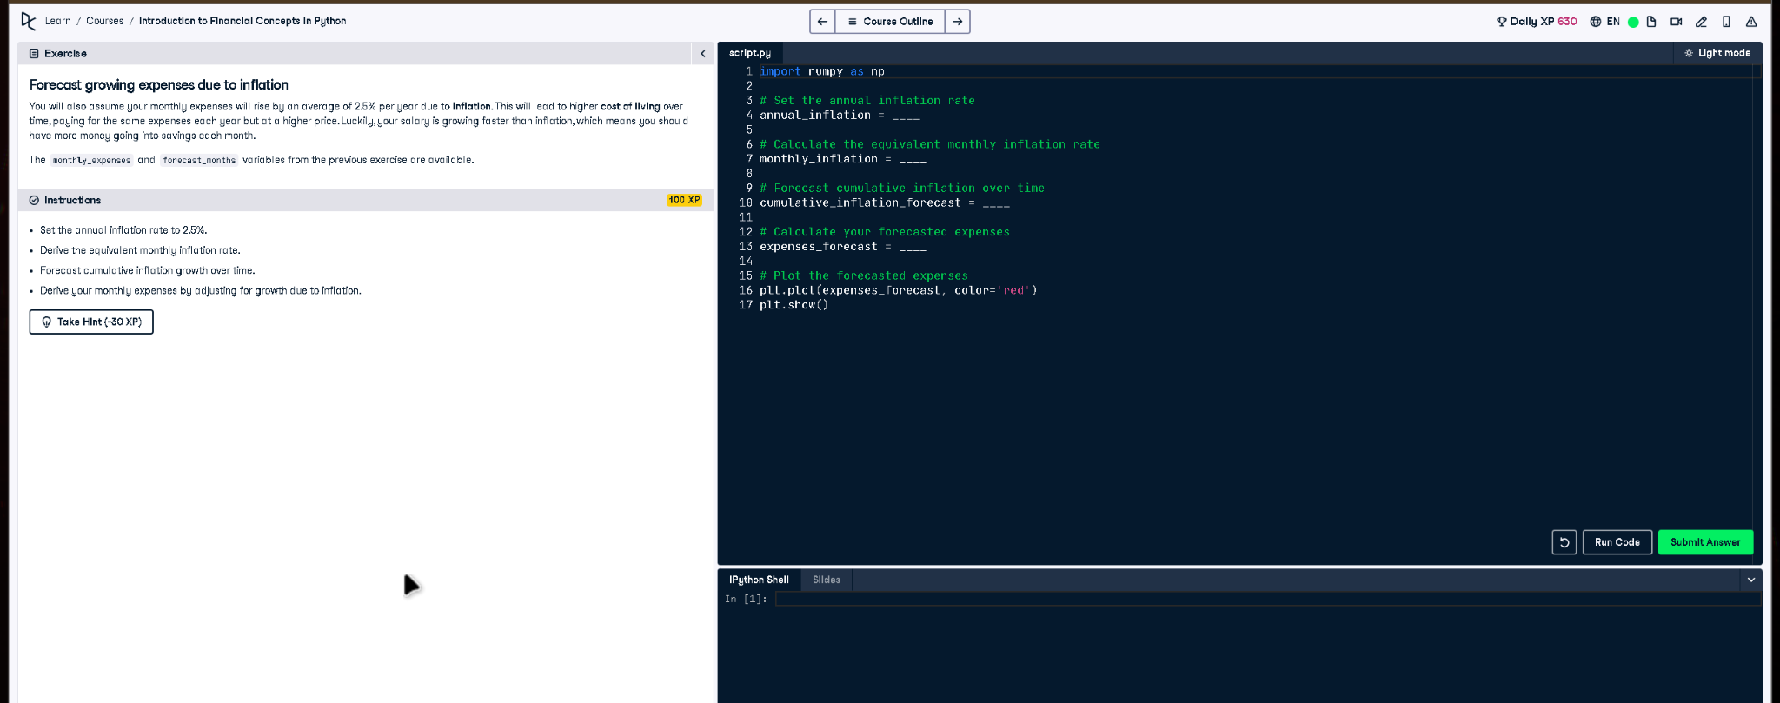

# Full Code Answer:

import numpy as np  
  
# Set the annual inflation rate  
annual_inflation = 0.025  
  
# Calculate the equivalent monthly inflation rate  
monthly_inflation = (1 + annual_inflation)**(1/12) - 1  
  
# Forecast cumulative inflation over time  
cumulative_inflation_forecast = np.cumprod(np.repeat(1 + monthly_inflation, forecast_months))  
  
# Calculate your forecasted expenses  
expenses_forecast = monthly_expenses * cumulative_inflation_forecast  
  
# Plot the forecasted expenses  
plt.plot(expenses_forecast, color='red')  
plt.show()

# Question:

How can you forecast monthly expenses over time accounting for a 2.5% annual inflation rate?

# 20-word Explanation (Question):

Forecasting inflation involves converting annual rates to monthly equivalents, enabling cumulative projections of rising expenses over long periods.

# Answer:

Convert the annual inflation rate to a monthly rate, use np.cumprod for cumulative growth, and multiply by expenses.

# 20-word Explanation (Answer):

Using np.cumprod on monthly inflation factors yields a cumulative inflation forecast, which adjusts monthly expenses for realistic cost increases.